**Database and Management System Lab**

NAME: PRIYANSHI VARSHNEY

ROLL NO: R2142230042

SAP_ID: 500119947

BATCH 2

B.TECH CSE, SEM-III

**PRESENTED TO**: Dr. Syed Sajid Hussain

# Experiment 17: To understand the concepts of Trigger.

**Objective:** Students will be able to implement the concept of trigger.

1. CREATE TRIGGER SALARY_VIOLATION BEFORE INSERT OR UPDATE OF SALARY, SUPERVISOR_SSN ON EMPLOYEE of experiment 3.

INPUT:

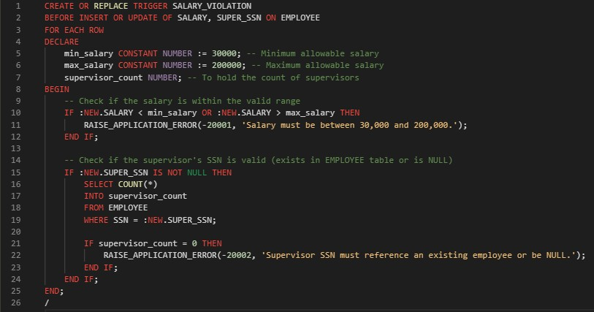

Valid Insert:

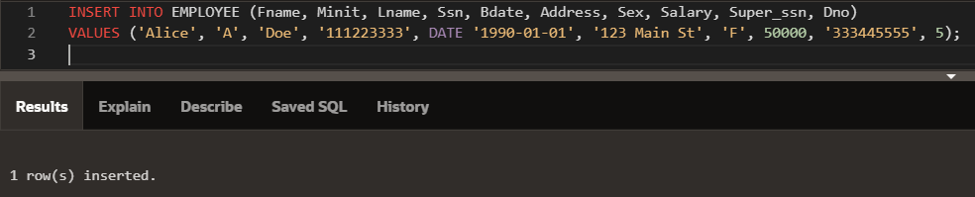

Invalid Insert:

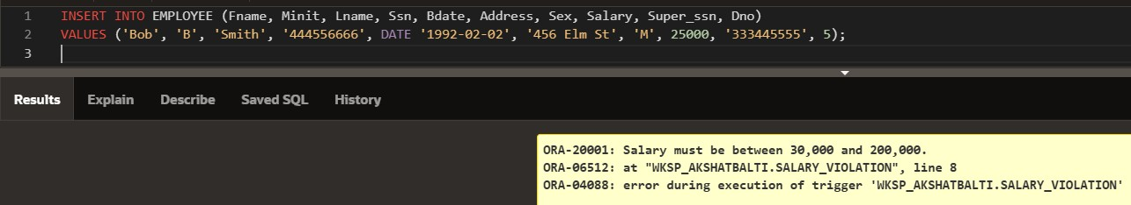

Invalid Update:

